# **Report on AWS Lambda and HTTP API Gateway Implementation**

## **Objective**

This project involves setting up an **AWS Lambda function** and an **HTTP API Gateway** to handle GET requests. The Lambda function extracts the personId parameter from the query string and prints it.

## **Step 1: Creating the AWS Lambda Function**

1. Navigate to the **AWS Lambda** console.
2. Click on **Create function**.
3. Select **Author from scratch** and enter the following details:
   * **Function Name:** PersonAPILambda
   * **Runtime:** Python 3.12
4. Click **Create function**.

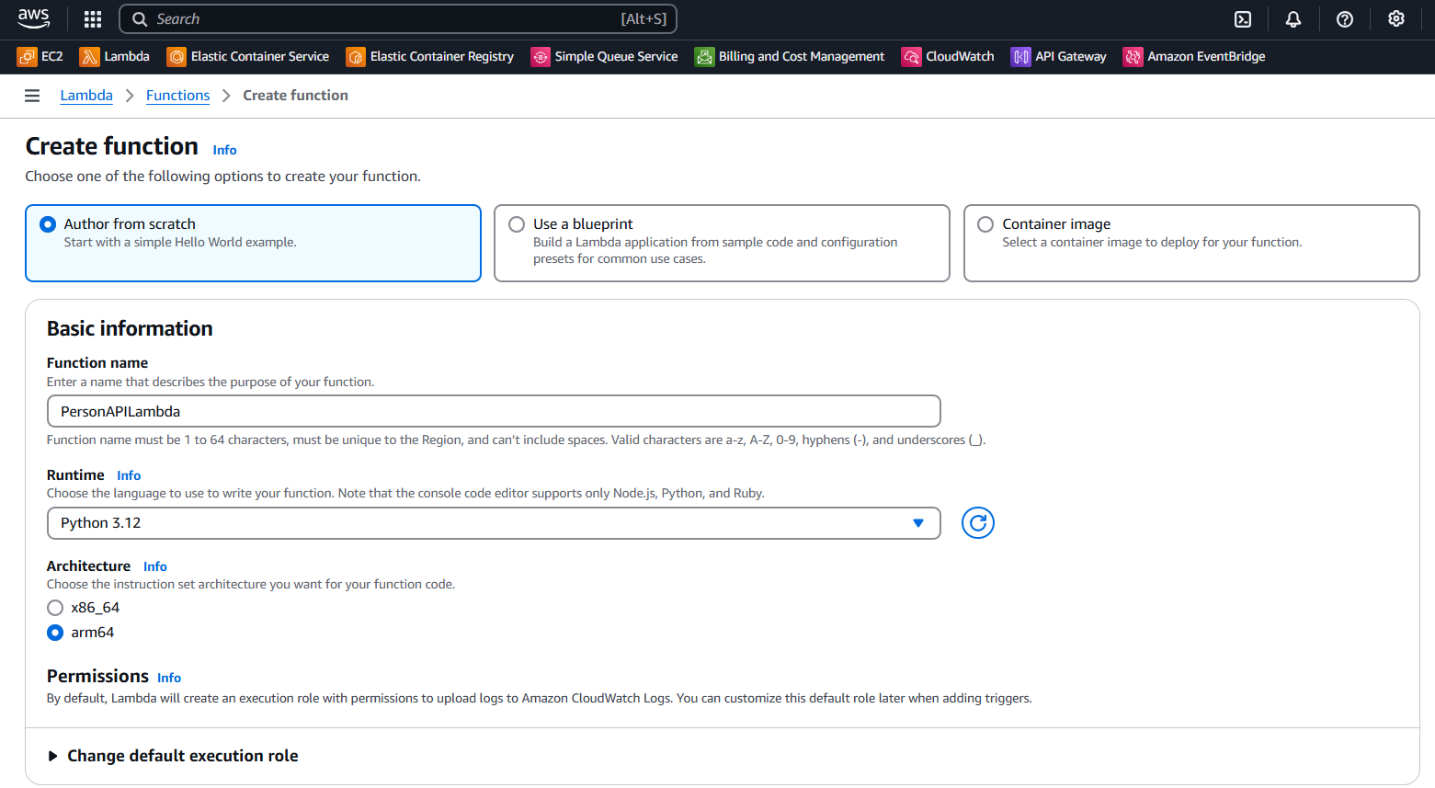

## **Step 2: Writing the Python Code**

1. In the **Code** tab of PersonAPILambda, replace the default code with the following script:

import json

def lambda_handler(event, context):

person_id = event.get("queryStringParameters", {}).get("personId", "Not Provided")

print(f"Received personId: {person_id}")

return {

"statusCode": 200,

"body": json.dumps({"message": f"Person ID received: {person_id}"})

}

1. Click **Deploy** to save changes.

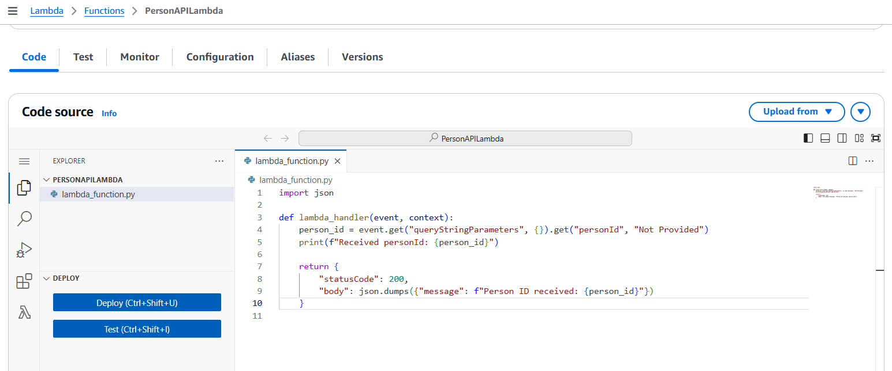

## **Step 3: Creating an HTTP API Gateway**

1. Navigate to the **Amazon API Gateway** console.
2. Click **Create API** and select **HTTP API**.
3. Click **Build** and enter the following details:
   * **API Name:** Person
   * **Stage Name:** $default
4. Click **Next** and choose **Add Integration**.
5. Select **Lambda Function** and choose PersonAPILambda.
6. Click **Next** and add a **GET route** with the following details:
   * **Route path:** /getPerson
   * **Integration target:** PersonAPILambda
7. Click **Create** to finalize the API setup.

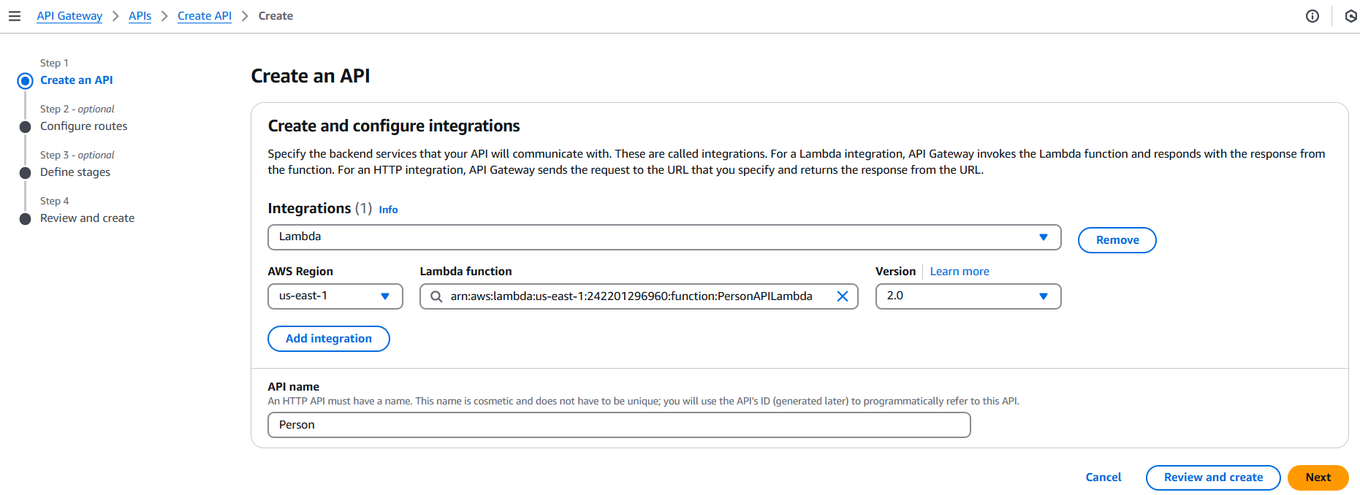

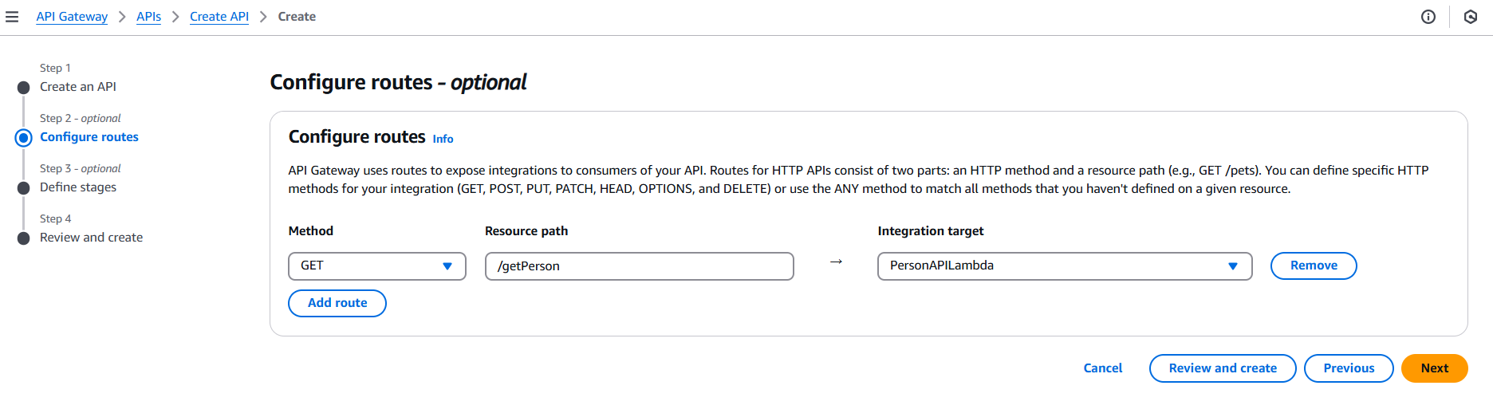

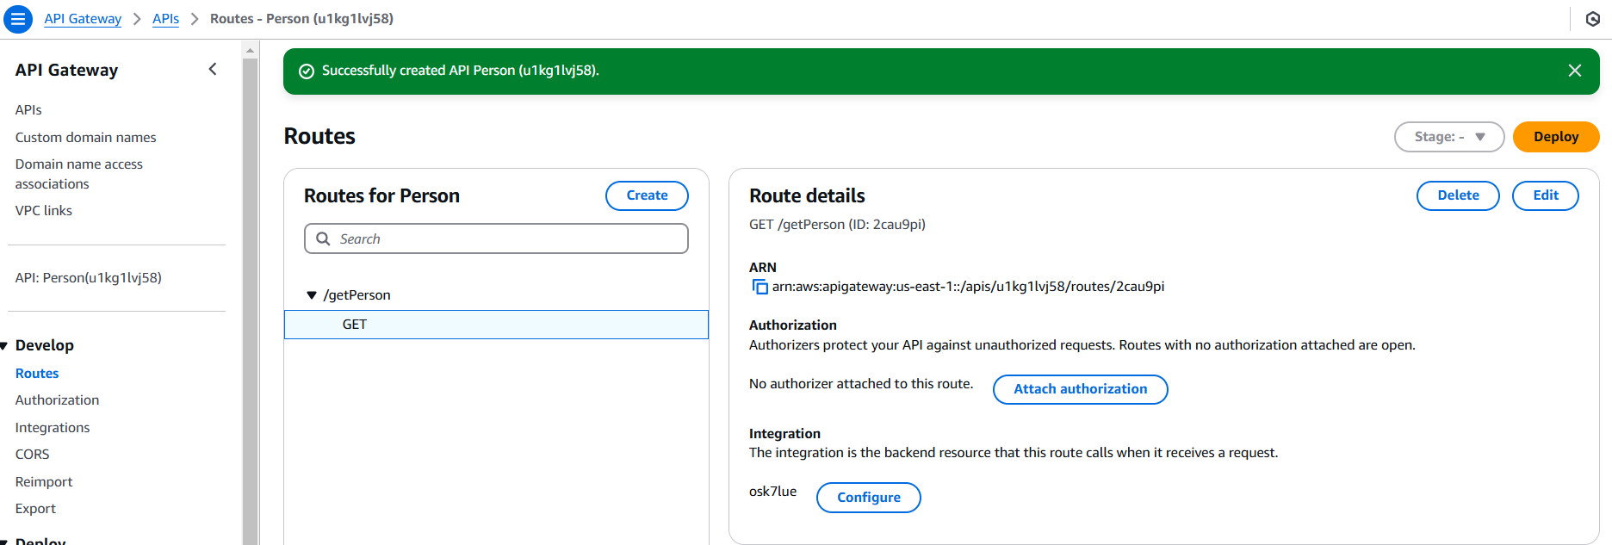

## **Step 4: Deploying and Testing the API**

1. Navigate to **API Gateway** and select the **Person** API.
2. Copy the **Invoke URL** from the $default stage.
3. Open a browser or use Postman to send a GET request:  
    <invoke-url>/getPerson?personId=6
4. Verify that the response contains the extracted personId.

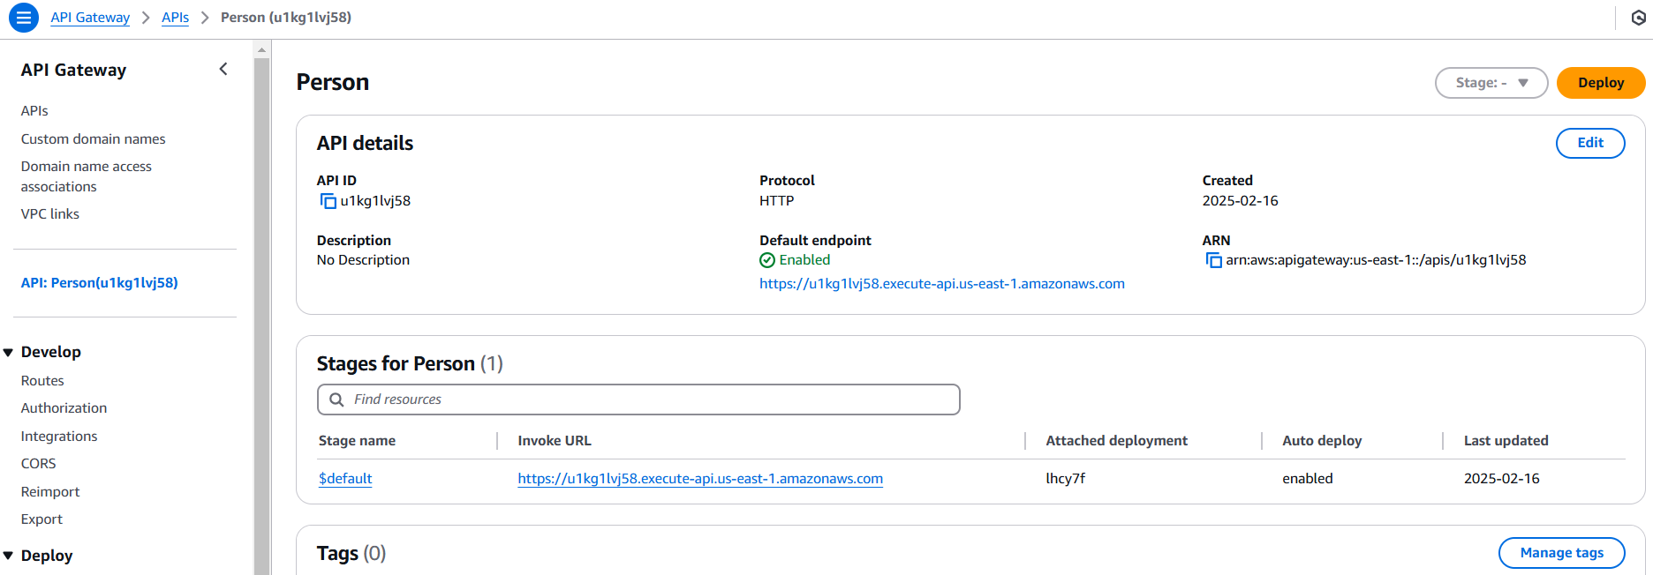

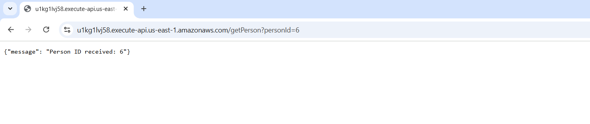

## **Step 5: Observing Logs and Metrics**

1. Navigate to **AWS CloudWatch** and open **Logs**.
2. Find the log group for PersonAPILambda.
3. Open the latest log stream and verify that the function logs Received personId: 5.

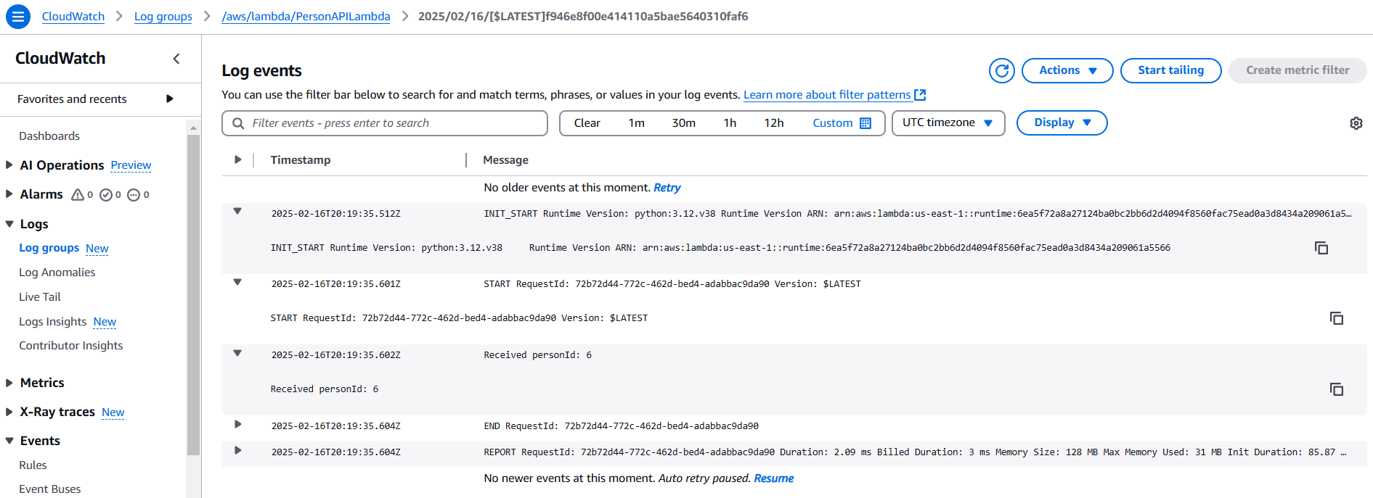

## **Conclusion**

The Lambda function **PersonAPILambda** was successfully set up and integrated with an **API Gateway (Person API)**. It correctly extracts the personId from GET requests and logs the value. The API is accessible using the HTTP route /getPerson?personId=<id>.

### **Next Steps**

* Add input validation to handle missing or invalid personId values.
* Implement error handling for edge cases.
* Enable authentication and authorization if needed.